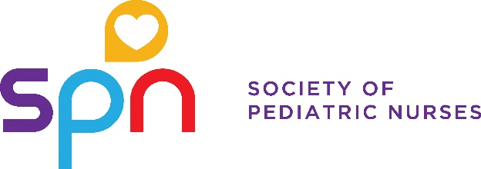

APGNN and SPN Recognizes
[NAME]

Upon the completion of the Pediatric GI Nursing Assessment-Based Program
and is awarded a certificate in

Pediatric Gastroenterology, Hepatology, and Nutrition Nursing

Presented on DATE – [Month, day, year]
Valid through [Month, year – 5 years from presented date]

